**SAMBHAV VARSHNEY**

Chandausi, +91 9548075560 , [sambhav.varshney_cs23@gla.ac.in](mailto:sambhav.varshney_cs23@gla.ac.in)

LinkedIn: https://www.linkedin.com/in/sambhav-varshney-5869212a8/ GitHub: [Sambhav-Varshney](https://github.com/Sambhav-Varshney)

# EDUCATION

**Pursuing Bachelor of Technology in Computer Science, *GLA University, Mathura 67%*** June 2027

**INTERMEDIATE-GLOBAL HERITAGE INTERNATIONAL School, Chandausi 64.6%** May 2023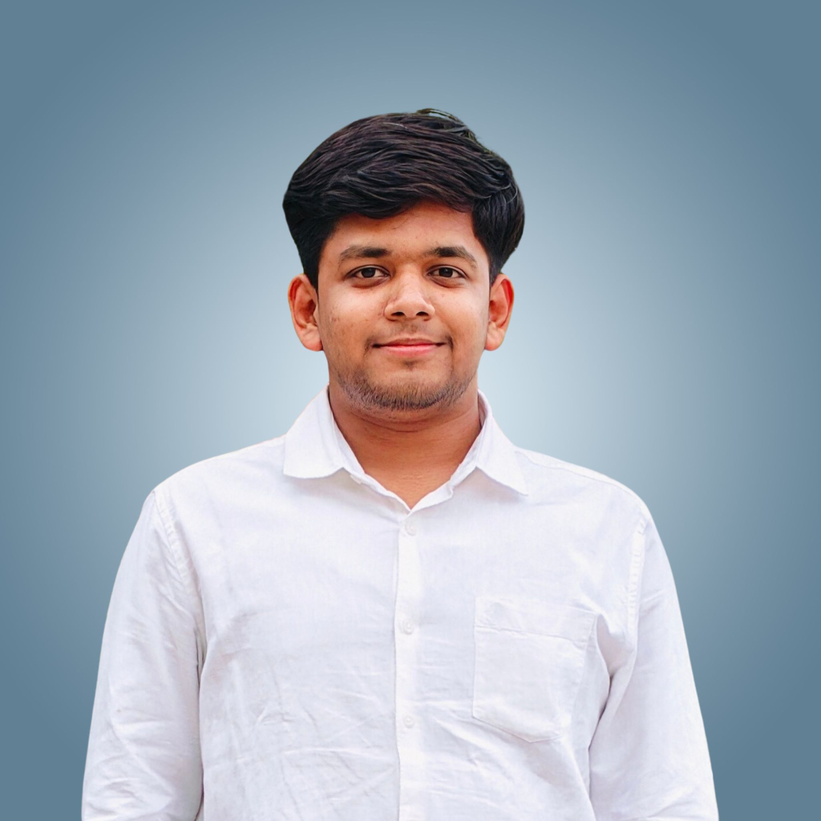

**HIGH SCHOOL -GLOBAL HERITAGE INTERNATIONAL School, Chandausi *81.2%*** May 2021

# INTERNSHIP/ TRAINING EXPERIENCE __________________________________________________________________

# BAOIAM Aug 2025 – Sep 2025

# *FullStack Developer Intern*

# Developed sample templates for company’s internal project using HTML, CSS and Javascript.

# Participated in the requirement gathering and prototype building process of software development.

# Job Oriented Value-Added Course, GLA University, Mathura June 2025 – July 2025

# *Trainee*

# Learnt basics of HTML, CSS , Java Script nd React.

# Post completing the training, created a Project named “”, by using Java Script.

# PROJECTS

* Mini Project Netflix clone.
* Tic tac toe Game by python.
* Myntra E-commerce Website.
* To-do app by Front End.

# SKILLS

**Technical Professional**

C, Python ,Java Effective Communication Skills

Html ,Css, JavaScript Team Work

Designs Creativity

# Soft Skills

* Problem Solving, Time Management, Team Management.

# PROFESSIONAL ACHIEVEMENTS/ INSIGHTS

* Certified in Machine Learning by Infosys Springboard.
* Participated in AINCAT 2025-India's Biggest Career Aptitude Test conducted by Naukri Campus.
* Attended workshop on English Learning Communication skills conducted by Dr. Ramanujam meganthan (NCERT).

# CO-CURRICULAR ACTIVITIES

* Liasoning Officer(LO)(Glance2.0, GLA, April, 2025).
* Participated in Two - days LSRW Workshop (GLA, 28,29March2025).
* Participated in the event”Creative Canvas-Poster Design Contest by IEEE student branch and WIE Branch on 27MAY2025.

**DECLARATION________________________________________________________________________________________**

I hereby declare that all the above mentioned information is true and correct to the best of my knowledge.